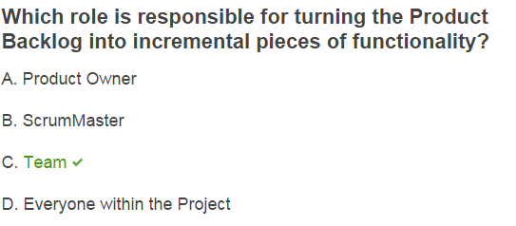

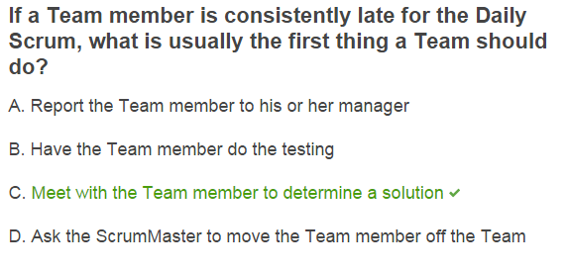

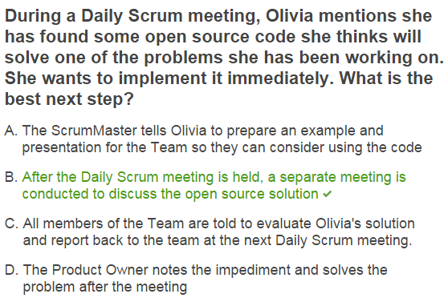

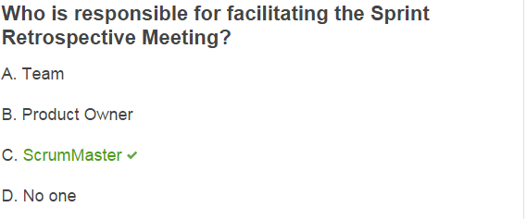

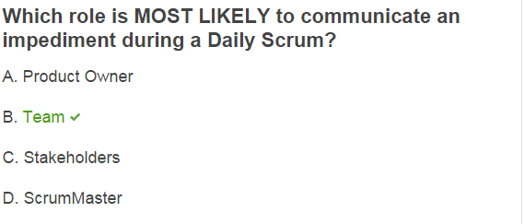

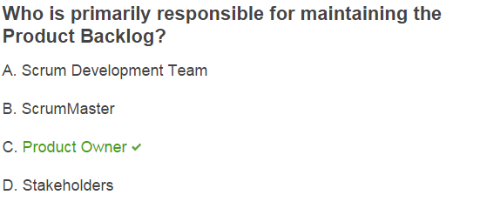

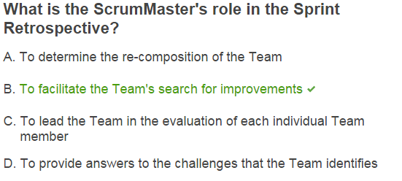

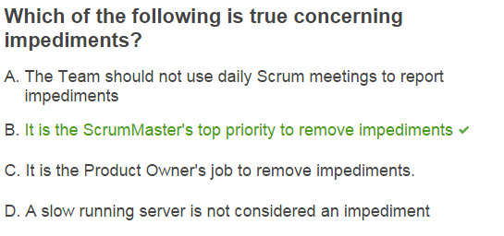

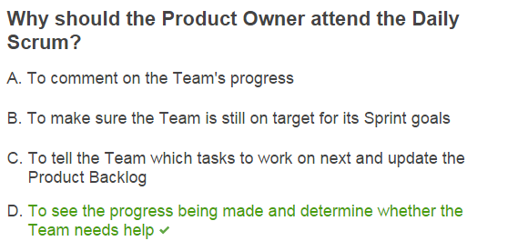

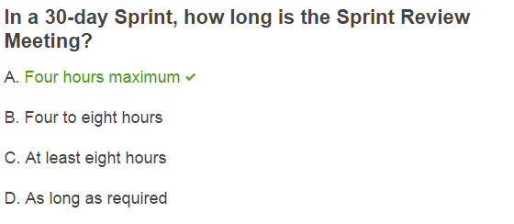

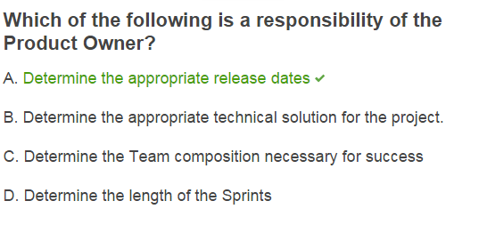

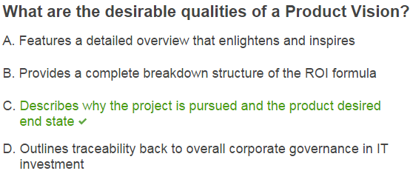

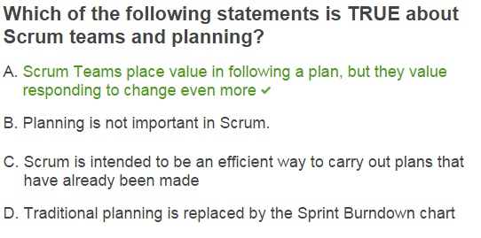

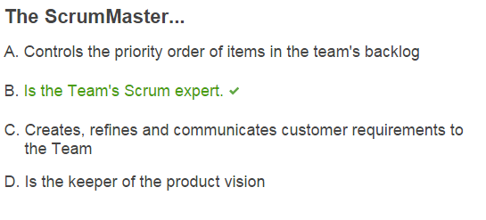

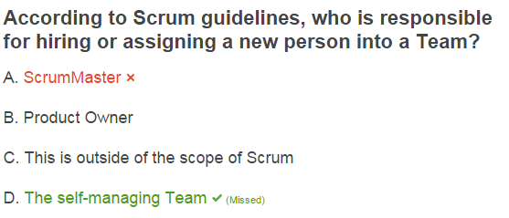

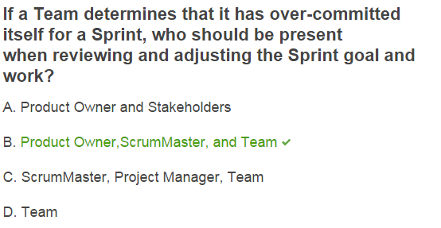

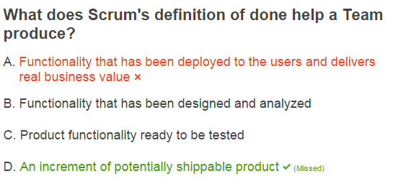

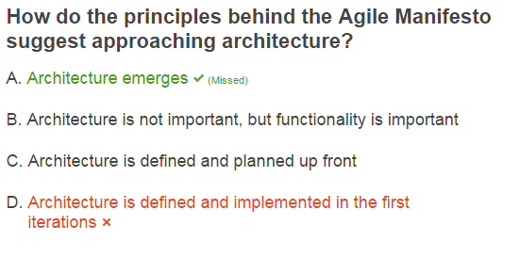

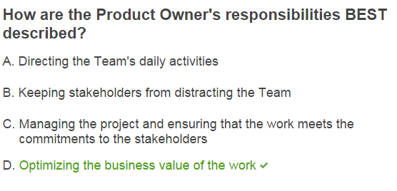

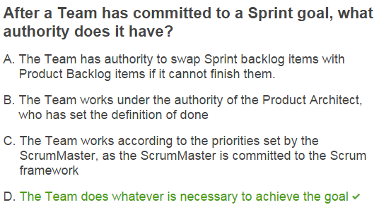

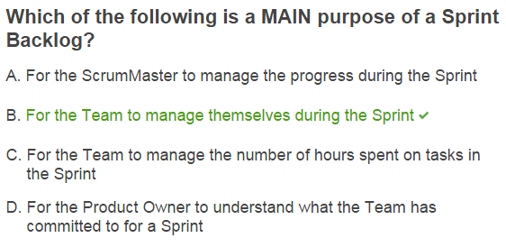

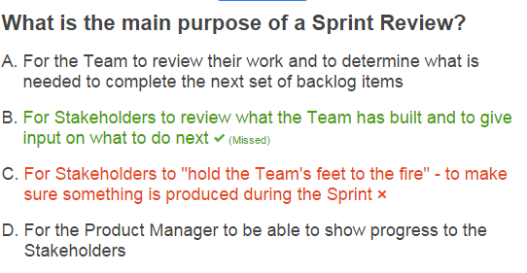

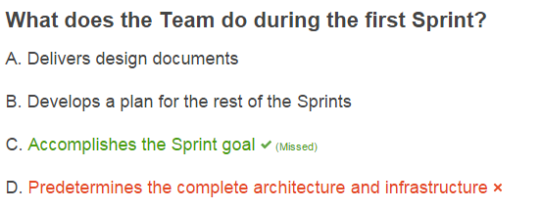

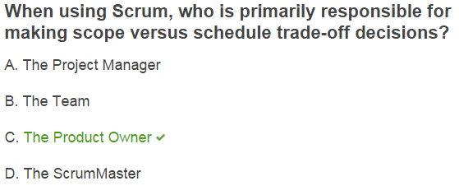

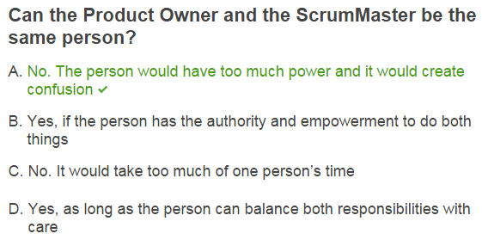

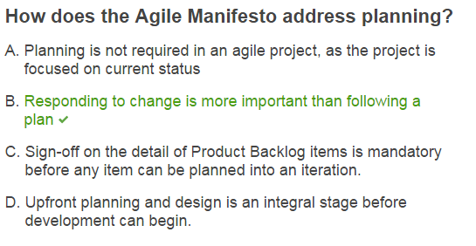

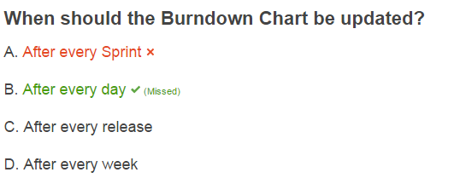

答案是sprint

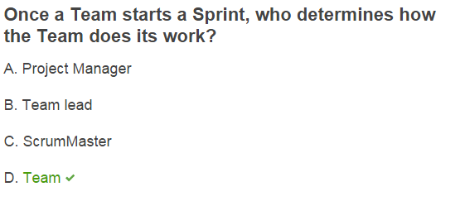

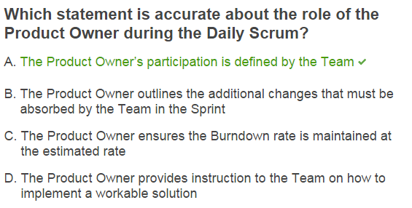

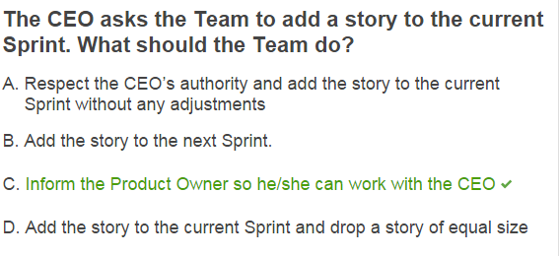

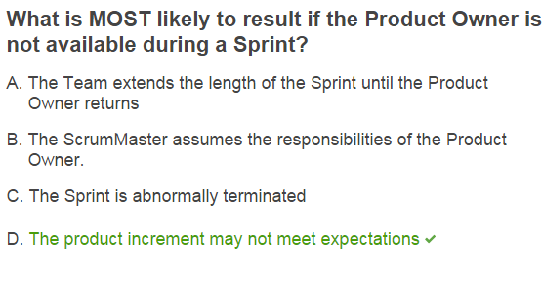

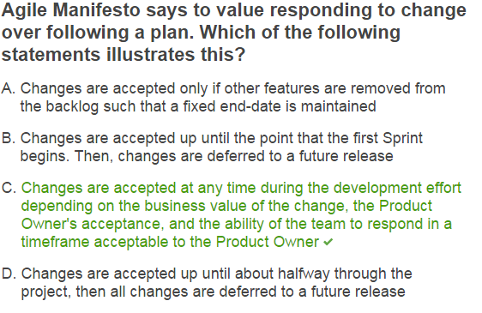

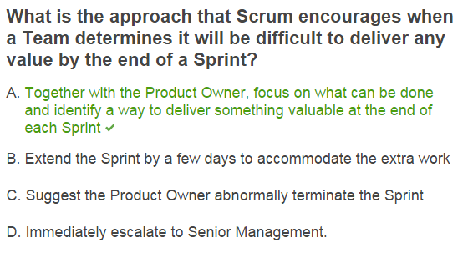

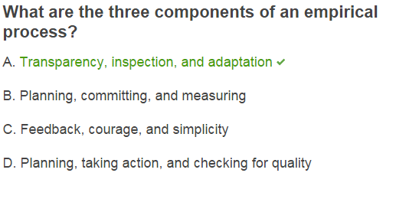

**Who is responsible for the business value delivered by a Scrum Team?**

**A) Product Owner**

**B) ScrumMaster**

**C) Project Manager**

**D) Program Sponsor**

**Who is primarily responsible for facilitation, when required, in Scrum meetings?**

**A) Development Team**

**B) ScrumMaster**

**C) Product Owner**

**D) No one**

**Which of the following best describes the Agile Manifesto attitude towards customer collaboration?**

**A) Consensus from customers is required before new functional requirements can be inserted into a Sprint.**

**B) Regular and frequent feedback from the customer is essential.**

**C) The Team must communicate what functionality will be produced in a Sprint and the goal of the Team for the release.**

**D) Collaborate closely with the customer and ensure all functionality is defined prior to the build phase of a project.**

**Which of the following is a characteristic of a good Scrum Team?**

**A) It seeks direction from the ScrumMaster.**

**B) It is self-organizing.**

**C) Its members all have similar skills.**

**D) It waits for tasks to be assigned to it.**

**What is MOST important according to the Agile Manifesto?**

**A) Documentation and planning**

**B) People and how they communicate**

**C) Control and management**

**D) Processes and tools**

**For what type of work is Scrum MOST suitable?**  
  
**A) Complex      
  B) Simple      
  C) Pre-defined      
  D) Low-risk**

**What should usually happen if, during a Sprint, the Product Owner identifies a new, important Product Backlog Item (PBI)?**  
**A) The ScrumMaster encourages the Team to include the extra item.      
  B) The Team works overtime to finish the PBI in the current Sprint.      
  C) The Product Owner adds the new PBI to the Product Backlog.      
  D) The Team extends the Sprint duration to include the new item.**

**What does the Product Owner do during a Sprint?**

**A) Guides the Development Team in its work**

**B) Clarifies requirements and answers questions**

**C) Intervenes when required to make sure the pace of work is sustainable**

**D) Protects the Development Team and the process**

**Who is primarily responsible for ensuring that everyone follows Scrum rules and practices?**

**A) Each individual team member**

**B) All Team members collectively**

**C) The ScrumMaster**

**D) The Product Owner**